A New Launcher for University Sounding Rockets

Fernando Calderon, Abd Al Chamas*, Thomas Wilson*, Adam Vore & Berton Vite*
Long Beach, CA, 90840

Abstract
The Department of Mechanical and Aerospace Engineering at California State University Long Beach sponsors two student rocket programs: The California Launch Vehicle Education Initiative (CALVEIN) that uses bipropellant liquid propulsion and the Experimental Sounding Rocket Association Club (ESRA) that flies solid propellant rockets. Because ESRA rockets reach apogees between 3 and 8 km they can have significant impact ranges. ESRA requires that all flight hardware be recovered intact within 2 hours of launch. Recovery is done by student teams on foot. To minimize recovery times the impact point must be controlled to keep it close to the launcher. Impact point location could be controlled by measuring the winds aloft and adjusting the launcher accordingly. Current launchers are not readily adjustable in elevation or azimuth, and their launch rails tend to be excessively flexible. We have designed and built our new launcher to meet our requirements for accuracy, adjustability, stiffness and transportability. The launcher rail sits on an azimuth turntable. Its elevation angle can be changed with an automotive scissor lift. A SkyScout™ is used for leveling the azimuth table, and measuring the launcher rail orientation relative to local vertical and true north. The launcher rail is supported by a ham radio tower truss to ensure the necessary stiffness. The entire launcher assembly is stabilized by 4 legs that can be folded for transport. The purpose of the launcher electrical subsystem is to safely and effectively supply current to the rocket igniter. This battery powered subsystem is housed in two separate boxes incorporating safety switches, a key-operated switch and a flip-up covered switch, a warning horn and continuity switches with buzzers. It is capable of launching a rocket from a remote location up to 500 feet away.

- Introduction
Sounding rockets and their launch systems are not new, but their use for educational purposes is. If they are to provide an effective environment for teaching engineering, the associated syllabi should include analysis and testing tasks. Otherwise, this activity degenerates into building and flying hobby rockets, although undeniably great fun, the results would not be sufficient in a proper educational learning experience to professional engineering standards.
One sounding rocket venue that does require analysis and testing is the Intercollegiate Rocket Engineering Competition (IREC) sponsored every year by the Experimental Sounding Rocket Association (ESRA). Student teams in the IREC are judged by several criteria¹:
- How closely their rocket approaches its target apogee. The competition has two classes, Basic (target apogee is 10,000 ft) and Advanced (target apogee is 25, 000 ft). Apogee is determined by a recording altimeter. A payload weighing at least 10 lbs must be flown.
- Whether or not their rocket was recovered intact and returned to the launch site within 2 hours of launch. Recovery is by student teams on foot searching the high desert environment near Green River, UT, in the summer. Walky-talkies and water are very important.
- The quality of the data returned by the payload.
- A Safety Report must be prepared, and its quality judged.
- An Engineering Summary Report describing the rocket and its payload must be prepared, and its quality judged.
- Written procedures must used to prepare and launch the rocket, and their quality will be judged.
- A briefing covering the material in the Engineering Summary Report must be presented to the judges for their consideration.
As can be seen, this is far from a Sunday afternoon hobby rocket fly-for-fun process.
The Advanced competition is significantly more difficult than the Basic one. Assuming a GPS transmitter and a homing beacon are flown the major challenge will not be locating the rocket and parachute; it will be the travel time to and from the landing site. A hypothetical situation illustrates this problem, where with an 8 km apogee and no wind compensation, the landing site can drift to an average of 10 km from the original launch site. Due to a lack of mobility of the launch site, the only means of travel to obtain the rocket post-launch is via foot travel. At 5 km/hr the results may lead to a 4 hour round trip in tough conditions.
The only remedy is to measure the winds aloft and adjust the launcher azimuth and elevation angles to bring the landing site within an acceptable area near the launch site. This paper addresses a launcher design to do this, something current off the shelf launchers can not do. The final product must also be transportable to and from Green River, UT. A final general set of considerations is that the launcher should be designed to minimize trajectory errors (dispersions).

- Requirements

All launchers can be described in terms of an architecture having a mechanical subsystem and an electrical subsystem.

A. Mechanical Subsystem Functional Requirements
- Transportable using “U-Haul” trailer or similar size and shape
- Ability to assemble and erect at the launch site using only manual labor & hand tools within a reasonable time frame.
- Ability to rotate about both Azimuth & Elevation axes independently
- Ability to level launcher platform to align Azimuth axis to the local vertical
- Have a zero tip off rail-lug combination
- Ability to replace the blast plate as needed
- Provide support to the electrical subsystem
- Ability to tilt the rail down to load the rocket without tipping over the launcher
B. Mechanical Subsystem Performance Requirements
- Elevation angle range: – 5 degrees to + 95 degrees
- Azimuth angle range: 0 degree to 360 degrees
- Ability to control both Elevation & Azimuth Angles: ± 0.5 degree
- Maximum launcher length while holding maximum bending deflection of the rail: 0.05 degree at a Quadrant Elevation of 80º
- Max rocket weight: 150 lbs (carried by launch lugs)
- Structural Margin of Safety: 3
- C. Mechanical Subsystem Environmental Requirements
- Dry Sandy Soil California Bearing Ratio (CBR) > 6
- Maximum ground slope: 5 degrees
- Corrosion resistant coatings in marine environments
D. Electrical Subsystem Requirements
- Length of wire run from launcher to control box: 500 feet
- Battery powered
- Use a key operated switch to check continuity and battery voltages without arming the firing circuit.
- Use a flip up switch to arm the ignition circuit
- Use a button to launch the rocket
- Provide audio warning devices

III. Mechanical Design
The first mechanical element to be discussed is the launcher rail. It uses 80-20™ precision aluminum extrusion with the slot milled to a wider width to eliminate tipoff. The design was first developed in the 1950’s at N.A.C.A. Wallops Station., where Fig 1 shows it in some detail. The main objective for this design is that both fore and aft lugs drop free at the same time, thus eliminating tipoff torques.
The 80-20™ is attached to a commercially available ham radio tower truss. The ham radio truss is made from three steel tubes in a tripod configuration welded together by steel rods in a “zigzag” like pattern as shown in Fig 2. After welding, each truss section is hot dipped in zinc for corrosion protection. It comes in 10 foot sections, which allows for the facilitation of transportation. The truss carries the 80-20™ on one of the three tubes. As shown in Fig 3, the truss also carries a blast plate to ensure no damage to the azimuth table occurs during launch of the rocket. The blast plate is carefully oriented to preclude a pitch torque from rocket plume impingement on the rail during launch. Estimates of the bending deflection of the truss assembly have been made². These show that a rail length of 20 feet will comply with the deflection requirement.
The launcher underpinnings resemble a large, four-legged spider as shown in Fig 4. The legs fold so the system can be transported in a dead spider configuration. The legs provide the necessary stability to prevent tipping during the launch of the rocket. The legs are adjustable so that they may provide a level top for the launcher over a gradient of the earth up to five degrees. The legs are conjoined to the base of the launcher via C-brackets, which mount to the base with two pins per leg. The pins effectively transfer the moment loads from the launch of the rocket efficiently to all four legs. The legs are initially installed at a 10 degree elevation relative to the surface of the ground to provide vertical clearance for the base of the launcher during launch.
The base of the launcher contains all the crucial components which allow precise alignment of azimuth and elevation angle thus minimizing the distance of impact from the rockets original launch location. Azimuth is controlled using a thrust bearing, or turn table device. The turn table is attached to the main base to one end, and the other end is attached to a circular plate of aluminum as shown in Fig 5. The main base contains 72 holes arrayed 5 degrees apart with .0005in tolerance to allow control of azimuth for the full 360 degrees. The turn table can support a vertical load of up to 200 lbs with a margin of safety factor of 3. The aluminum circular plate supports two brackets that hold two triangular plates normal to the base. These triangular plates, as shown in Fig 6, support a smaller rectangular plate of aluminum in which the truss mounts to. This plate provides the truss the ability to change the elevation angle via a 1.5 ton scissor jack located in between the larger circular and smaller rectangular plate. The elevation is controlled by adjusting the height of the scissor jack, measured using a SkyScout™, and a tubular spirit level (bubble level). Final launcher rail adjustments are made using azimuth and elevation measurements from the SkyScout™
The blast plate protects the base from plumes generated by the rocket during lift-off. The plate is attached truss and the 80-20™ aluminum extrusion for stability. The blast plate is comprised of a quarter inch plate of steel which diverts the plume away from the base.
This design meets all of our requirements, allowing for a successful launch recovery. The final base assembly can be seen in Fig 7.
IV. Electrical Design
The purpose of the electrical sub-system of the launcher is to safely and effectively supply sufficient current to the rocket igniter in order to launch the rocket. The sub-system is battery powered and consists of two separate components incorporating safety switches, including a key operated switch and a flip up covered switch, warning horn, continuity switches with buzzers, and is designed to launch the rocket remotely.

The need for a new electrical sub-system for our launcher has propelled us to design and build a safe, portable, and effective electrical launcher. While convenience is beneficial in any design, the main focus of the launcher's electrical system is safety and reliability. The electrical sub-system of our launcher is composed of two components; the proximal box, which is 50ft away from the rocket, and the distal box, which is 500ft away from the launcher.

The proximal box is connected to the rocket igniter through a 14 gauge lamp cord with a port for easy connection on the side of the unit. The box contains a 12V sealed lead acid (SLA) battery that powers the complete electrical sub-system and a printed circuit board to control the relay and continuity switches. The proximal box also contains a multitude of safety features to ensure that no current is supplied unless the rocket is ready for launch. A continuity switch, which uses a momentary button switch, with a small buzzer attached has been installed to check continuity between the firing leads on the proximal box; this is done to remotely check the status of an igniter before launch or in the case of a misfire. A small car horn is installed in the proximal box that warns any bystanders that the rocket is armed and nearing launch. In addition to the continuity switch and the horn, a safety switch is installed at the proximal box that will not allow any current to flow to the rocket unless it is switched on; this guarantees the safety of anyone forward of the proximal box by allowing them to manually lock out any launch commands.

Figure 8 shows a schematic diagram of our circuit design. In Fig 9, it is shown as it has been implemented,

V. Future Work

While we have designed and built a new launcher, but it has not yet been used for an actual launch. Our next task is to use it for our ESRA flight tests in May. Also, there is some limited evidence form tests done in the 1960’s that very high rocket structural loads can occur while the rocket is still on the launcher. We hope to instrument our launcher in the future to explore this issue.

VI. Conclusions
We have generated requirements for a new launcher, and used these to guide the design and fabrication of our new launcher. Our design incorporates new features not previously employed in a university sounding rocket program, and we expect great things from it in this year’s ESRA competition.

VII. Acknowledgements

We would like to express our thanks to Prof. Charles Hoult and Dr. Janet Hoult for their guidance and help in accomplishing this project.

References
- ESRA web site
- C.P. Hoult, “Launcher Tipoff Deflection”, RST memo, 28 August 2010
t+
w+
b
b
Section b-b
Section a-a
a
a
a
View of the bottom of the Rail looking up
Free end
L
L
c
c
d
d
w
t
W
W+
Section c-c
Section d-d
Side view of Rocket and Riding Lugs

Figure 1 Zero Tipoff Launcher and Lugs

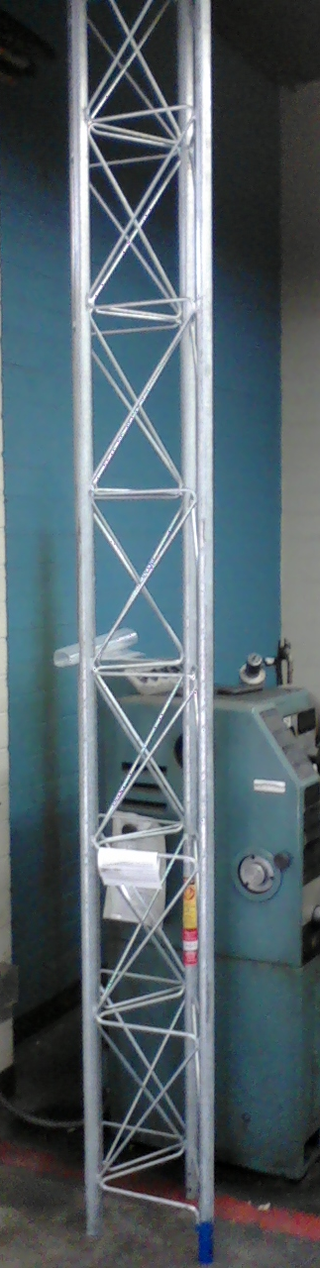
Figure 2. Truss

Launcher Rail Truss
Quadrant Elevation Hinge
Azimuth Turntable
QE
Rocket Thrust C
Blast Plate
Lateral Offset
Longitudinal Offset
Truss Depth
Figure 3. Arrangement of the Base of the Launcher Rail

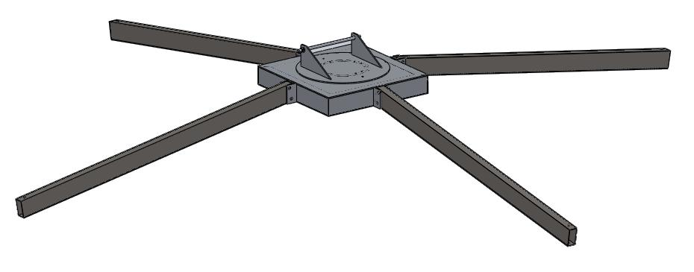

Figure 4. Launcher Underpinning

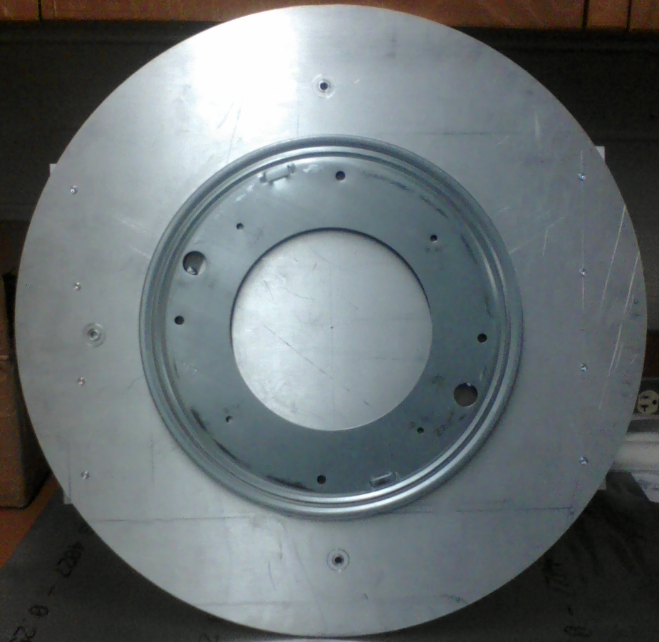

Figure 5. Thrust Bearing Device (Turn Table)

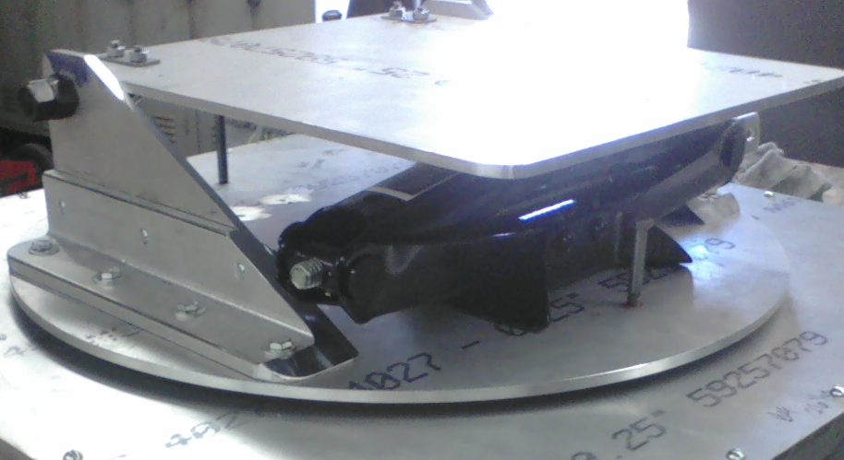
Figure 6. Base Support and Scissor Jack for Elevation Angle Manipulation

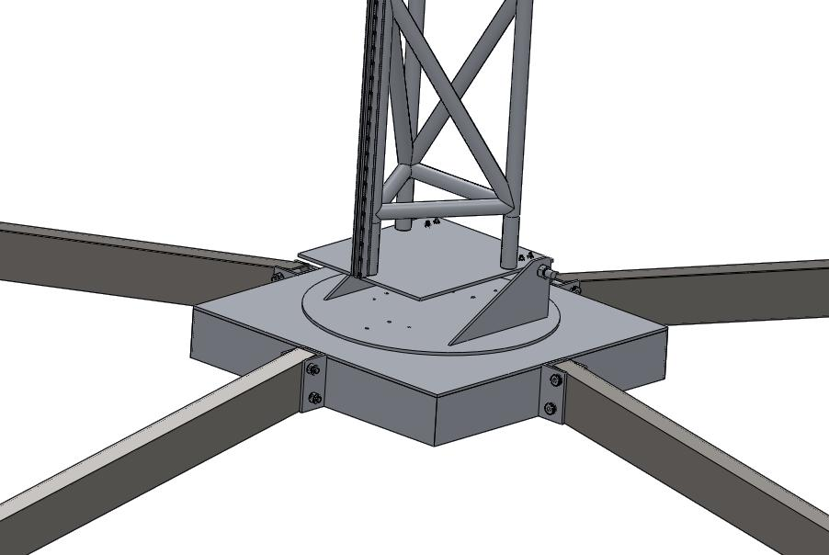
Figure 7. Launcher Base Assembly

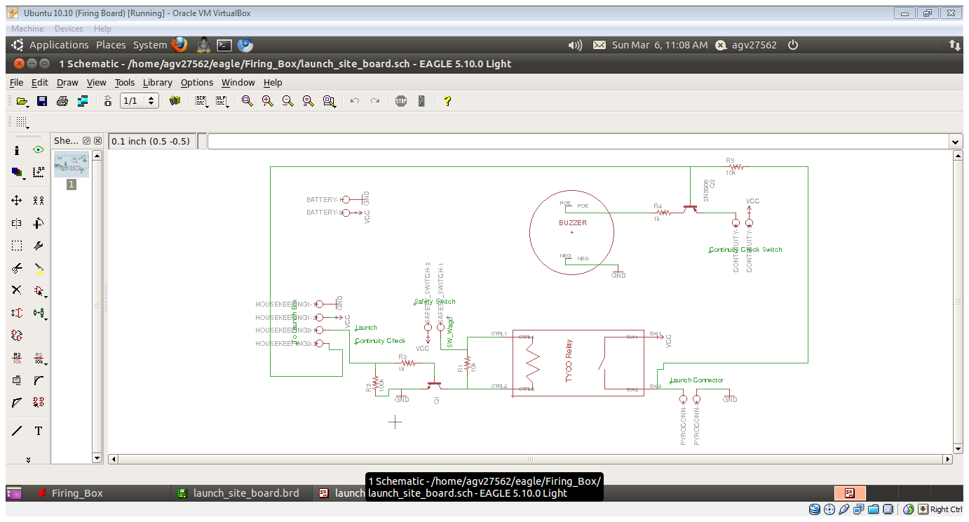
Figure 8 Circuit Diagram

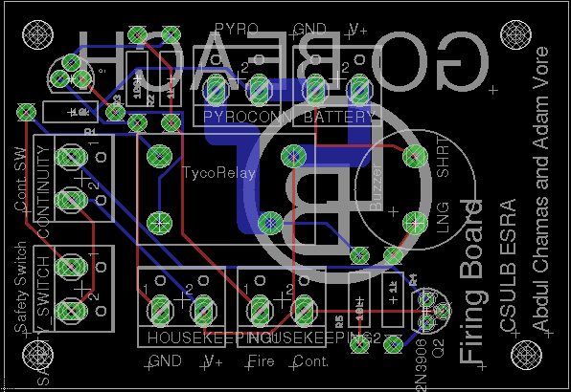

Figure 9 Printed Circiut Board

Undergraduate student, Department of Mechanical and Aerospace Engineering, California State University Long Beach, 1250Bellflower Blvd., AIAA student member
Graduate student, Department of Mechanical and Aerospace Engineering, California State University Long Beach, 1250Bellflower Blvd., AIAA student member

